Gamma News – Unfolding Here 1
January 2024

January Meeting January 6, 2024 – 11:30-1:30
We’ll be meeting at the North Las Vegas Airport Café Sunshine and Tailwinds. It is in the terminal building, on the 2nd floor [the elevator is just inside the door on the right]
Address [It’s just off of Rancho and there is a light]
2730 Airport Dr, Ste. 101
Telephone: 702-261-3803

Activity: Think about a book you enjoyed [or hated] and let us know your recommendation… This does not have to be current! Loved a book you read as a kid? Share it! Hated something they made you read in high school? Let us know. Love/hate, current or not – it’s all about books!
Basket provided by Vivian

February Meeting Saturday, February 10, 2024 from 11:30-1:30
Margo Thayer’s home - 7215 W. Tara Ave, 702-222-9878
Activity: We might possibly have a speaker. Otherwise we’ll be sharing a few words about Great Women in our families.
We need to select a Rose of Recognition for this year
We also need a nominating committee as this is the year we vote for chapter officers. Think about if you want to volunteer [either for the committee or as an officer]
Basket provided by Joyce

Thinking Ahead to Founder’s Day
We are hosting Founder’s Day this year. When this was discussed early in the year, everyone seemed to think a fancy tea would be a great idea. Based on the research I have done, it would be very expensive [not to say time consuming] to try to put this on ourselves. When Judy did it last time [and did it superbly] there was an overwhelming amount of work and expense involved.
Although she has reserved the community room that we used last time for us [which is lovely site], set up would be both difficult and time consuming. We would have to provide tired tea trays, cups, saucers, tea pots, plates, and of course, food.
We would have to set up the tiered trays with the appropriate items. I believe a traditional display is savories [like tea and finger sandwiches], sweets [like cake, cupcakes, and cream puffs], fruits [like tarts or small amounts of fresh fruit], cookies and scones [scones are usually accompanied by jam and/or clotted cream]. We would need to provide tea pots with boiling water and an assortment of teas. We would need to provide refills for the tea pots as needed. Then we would need to clean and remove everything.
Bottom line: I think the logistics and expense for ‘do it ourselves’ would be overwhelming.
So I think we should consider ‘going out’ for this and I have the following two suggestions to make:
The Tea Terrace. It’s located near 215 and Rainbow [6830 South Rainbow Boulevard #140]. These are the different teas they offer https://the-tea-terrace.com/menu-1 I was there with a friend a year ago and the Queen’s Tea was excellent.
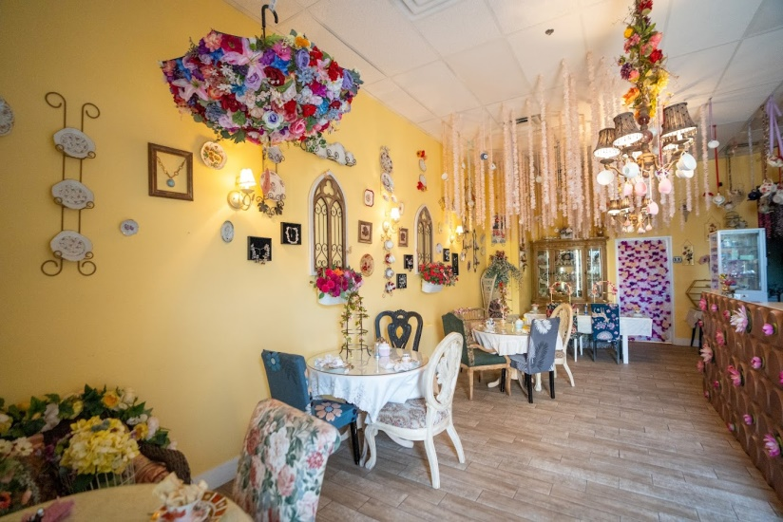
The Queen of Hearts. It’s located in Henderson [2895 N Green Valley Pkwy Suite D] It’s fancier and the items served are fancier – but the price is higher. https://www.queenofheartsvegas.com/menu I was there with another group a year ago and the quality was excellent.
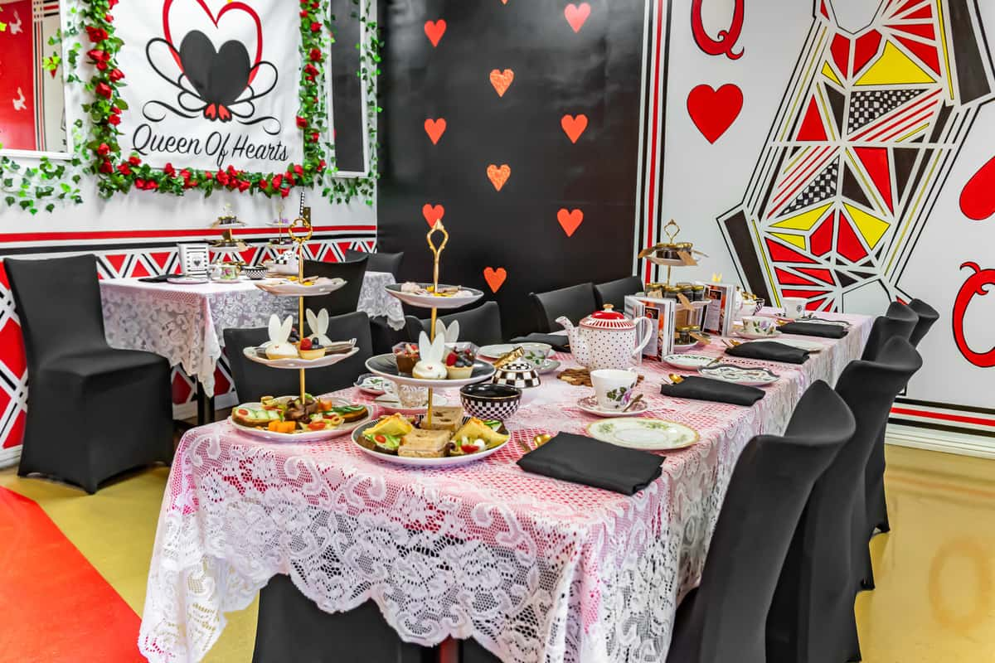
So spend some time thinking about it, check out the websites, and make comments and suggestions of other sites…either at the meeting or via email.

Trivial Pursuit #4 – Happy New Year!
- From what Roman god does the month of January get its name?
- On what calendar is Chinese New Year based?
- What is the translation of the title of the song “Auld Lang Syne”?
- What food do people in the Southern United States often eat for good luck on New Year’s Eve?
- On what date was New Year’s celebrated in ancient Rome?
- What Australian city has one of the largest New Year’s celebrations?
- At one minute before midnight in Spain, twelve of what is eaten before the clock strikes for the New Year?
- In what ancient country were eggs given as gifts on New Year’s Day?
- What is one of the top New Year’s resolutions?
- When was the first Tournament of Roses in Pasadena, California?
- If you are in Scotland on New Year’s eve, who do you kiss at midnight?
- Who was the first broadcast host of the Times Square New Year’s Eve celebration?
- Which calendar is used most widely in the world today and upon which is based a January 1st New Year?
- What was the first year there were fireworks for the New York New Year’s Eve celebration?
- True or False? The earliest known New Year’s celebration was 4,000 years ago in Mesopotamia.

